Creating a Psychology Research Poster

There are two primary purposes for a poster session: (1) a person can quickly see a large number of research findings, and (2) a person has immediate access to the authors of the research and can ask questions. Information about a typical, empirical poster is described below. In addition to your actual poster, you should also prepare the following:
- A short (5-minutes or less) verbal "blurb"
  - The purpose of this blurb is to quickly explain what you did and what you found.
  - This quick summary should be geared toward an audience who wants the "bottom line" on your research and wants it expressed in an interesting, non-technical way.
Your Poster
One way of creating the physical poster is to print it on multiple sheets of regular paper and attach it to a poster board. The alternative is to print it on a single sheet of large paper. In general, note the following:
- You need an introduction, method, results, discussion, references, and (if relevant) figures or tables
- Arrange your work such that the sections flow from top to bottom in columns, such that one line does not stretch across the span of your entire poster. Below is just one example of a possible layout:
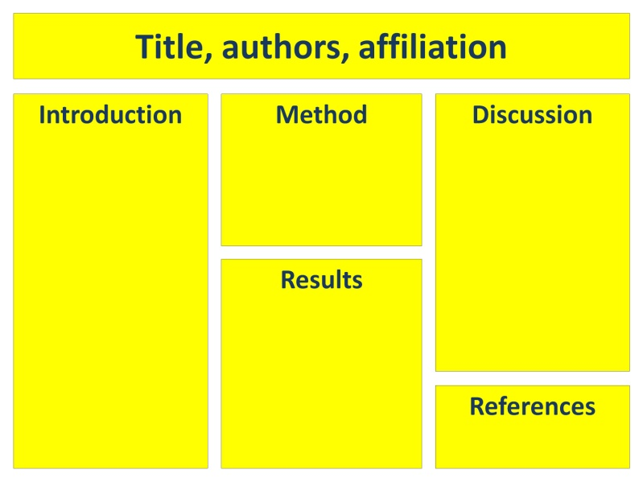
- Use a large font that can be read from a distance (i.e., at least 20 point). Your references can be in a smaller font.
- You can use bullet points to organize your ideas, but write in complete sentences. Unlike a PowerPoint presentation used during an oral presentation, someone viewing your poster should be able to read your poster and understand the project without necessarily talking to you.
- Note that you will probably have to pick and choose the most central aspects of your project to report, given the relatively small amount of space allowed. For example, you might want to choose the one most relevant or glaring "limitation/qualification" to write about rather than listing every limitation you can think of.
- Use APA style, triple check your numbers, and proofread.
- You need to cite your sources in the text of the poster. Note that you can automatically use "et al." anytime there are three or more authors.
Don't forget
- Have fun! You know more about your own research project than anyone else in the room. Take advantage of this opportunity to talk about what you found interesting about the topic, and get involved with conversations with other researchers on their topics.

